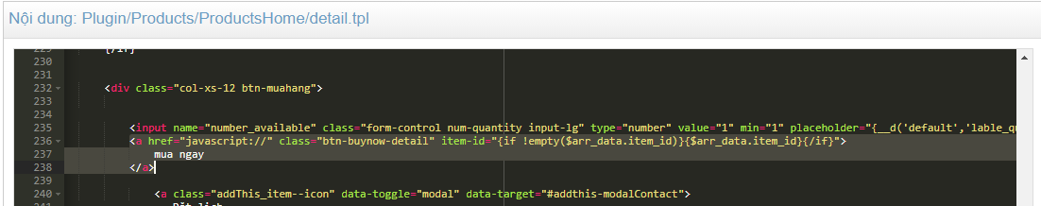

<a href="javascript://" class="btn-buynow-detail" item-id="{ if!empty($arr_data.item_id)}{$arr_data.item_id}{/if}"> mua ngay </a>